
Value for Money Statement

Date approved by Directors: | 28th March 2022
Board Review Date: | 27th March 2023
Body Responsible for Review: | Resources Committee

Commitment to Equality:
We are committed to providing a positive working environment which is free from prejudice and
unlawful discrimination and any form of harassment, bullying or victimisation. We have developed.
a number of key policies to ensure that the principles of Catholic Social Teaching in relation to
human dignity and dignity in work become embedded into every aspect of school life and these.
policies are reviewed regularly in this regard.
This Value for Money Statement has been approved and adopted by Emmaus Catholic Multi Academy Company on 28th March 2022 and will be reviewed in March 2023

Signed by Director of Emmaus Catholic MAC: J GRIFFIN

Signed by CSEL for Central Team: S HORAN

Schools to which this policy relates:

Signed by Principal for – Hagley Catholic High School
Signed by Principal for – Our Lady of Fatima Catholic Primary School:
Signed by Principal for – Our Lady & St Hubert’s Catholic Primary School:
Signed by Principal for – St Ambrose Catholic Primary School:
Signed by Principal for – St Francis Xavier Catholic Primary School:
Signed by Principal for – St Gregory’s Catholic Primary School:
Signed by Principal for – St Joseph’s Catholic Primary School
Signed by Principal for – St Mary’s Catholic Primary School:
Signed by Principal for – St Philip’s Catholic Primary School:
Signed by Principal for – St Wulstan’s Catholic Primary School:

Definitions
In this Value for Money Statement, unless the context otherwise requires, the following expressions shall have the following meanings:
- ‘School’ means the school named at the beginning of this Value for Money Statement and includes all sites upon which the school undertaking is, from time to time, being carried out.
- ‘Multi Academy Company’ (Emmaus Catholic MAC) means the company responsible for the management of the School and, for all purposes, means the employer of staff at the School.
- ‘Board’ means the board of Directors of the Multi Academy Company.
- ‘Chair’ means the Chair of the Board or the Chair of the Local Governing Body of the school appointed from time to time, as appropriate.
- ‘Clerk’ means the Clerk to the Board or the Clerk to the Local Governing Body of the School appointed from time to time, as appropriate.
- ‘CSEL’ means the Catholic Senior Executive Leader (CEO equivalent) employed by the Company.
- ‘Companion’ means a willing work colleague not involved in the substance of the employee’s performance under review by this Value for Money Statement, or an accredited trade union representative or an official employed by a trade union who will be expected to make themselves available for the periods of time necessary to meet the timescales under this Value for Money Statement.
- ‘Diocesan Schools Commission’ means the education service provided by the diocese, which may also be known, or referred to, as the Diocesan Education Service.
- ‘Directors’ means directors appointed to the Board of the Multi Academy Company.
- ‘Governing Board’ means the body carrying out the employment functions of the Multi Academy Company and such term may include the Board and/or a Local Governing Body of the School.
- ‘Governors’ means the governors appointed and elected to the Local Governing Body of the School, from time to time.
- ‘Local Governing Body’ means the group of governors appointed and elected to carry out specified functions in relation to the School as delegated by the Multi Academy Company.
- ‘Vice-Chair’ means the Vice-Chair of the Board or the Vice-Chair of the Local Governing Body of the School elected from time to time, as appropriate.

INTRODUCTION
Value for Money is a statutory duty to secure continuous improvements in the way that services and functions are exercised by the most economic, efficient and effective means possible. Whilst value for money does not apply statutorily to Local Governing Bodies, schools are expected to demonstrate that they are following value for money principles in their expenditure of public money, and as part of their evaluation of standards, the curriculum, and partnership with parents and management. This is not a new process, but an opportunity to build on what the Multi Academy Company has already achieved.

FINANCIAL GOVERNANCE AND OVERSIGHT
The Board of Directors is accountable for the way in which schools’ resources are allocated to meet the objectives set out in the School Development Plan. This responsibility is delegated to the individual Local Governing Body with oversight by the Board. The Company needs to secure the best possible outcome for students, in the most efficient and effective way, at a reasonable cost. This will lead to continuous improvement in the schools’ achievements and services.
The Board of Directors approves the budget each year and is mindful of the need to balance expenditure against income to ensure the Multi Academy Company remains a ‘going concern’. The Board of Directors receives and approves the Annual Accounts and External Auditors’ Management Letter.

BETTER PURCHASING
The Catholic Senior Executive Leader (CSEL)/Accounting Officer (AO), supported by the Finance Office, is always striving to find value for money in terms of suitability, efficiency, time, and cost. Measures already in place include:
- all goods/services ordered with a value over £15,000, or for a series of contracts which in total exceed £15,000 must be subject to formal tendering procedures. At least three written estimates shall be obtained for all orders between £5,000 and £15,000.
- all goods procured between £500 and £5,000, budget holders should obtain and retain evidence of the three prices from potential suppliers. These can include screen shots of web- based prices which should be printed off and saved.
- procedures which minimise office time by the purchase of goods or services under £500 direct from known, reliable suppliers (e.g. stationery, small equipment), budget holders can use their best judgement but must shop around to obtain value for money as a matter of routine.
- Tender exercises are regularly undertaken to ensure that high value contracts are assessed against the marketplace on a regular basis that long term contracts remain competitive.

ASSESSING VALUE FOR MONEY
The National Audit Office (NAO) uses three criteria to assess the value for money of government spending i.e. the optimal use of resources to achieve the intended outcomes:
- Economy: minimising the cost of resources used or required (inputs) – spending less;
- Efficiency: the relationship between the output from goods or services and the resources to produce them – spending well;
- Effectiveness: the relationship between the intended and actual results of public spending (outcomes) – spending wisely.
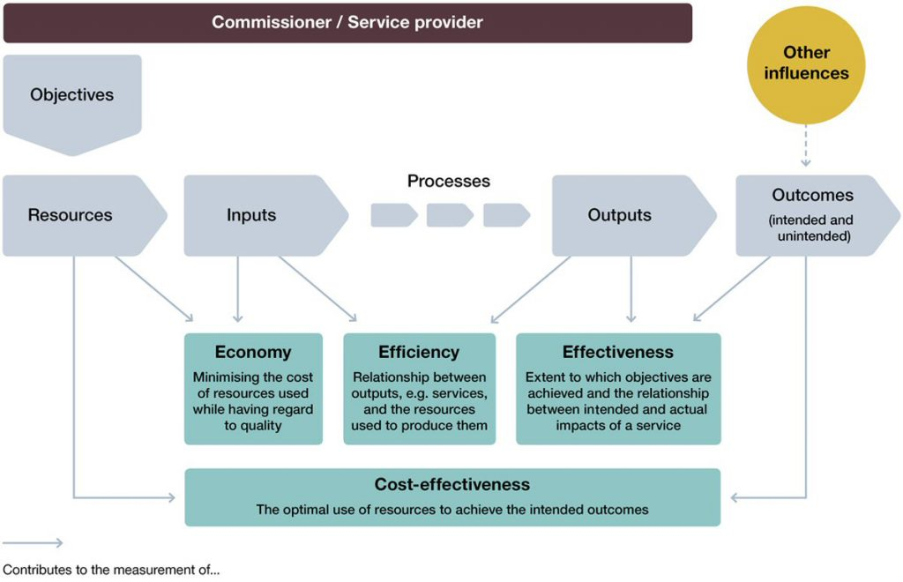
The Company recognises the importance of ensuring that financial relationships with suppliers are cost-effective in order that good value for money is achieved.
Poor value for money means either that:
- more needs to be spent to achieve the expected outcomes, leaving less money for other programmes, services, users and outcomes; or
- the impact of the programme or service is less: fewer users receive the expected benefits or outcomes; or all or some users benefit less than they should.

FOCUS AREAS FOR VALUE FOR MONEY
The Company is committed to constantly analysing the measures that need to be taken to increase cost-effectiveness in actual financial relationships with suppliers by focussing on the areas below:.
Impact: Ensuring spend is focused on outcomes.
- Priorities: Ensuring sure spend is focused on those outcomes which meet the priorities of the Company
- Taking a long-term view: where possible. seeking the optimal combination of:
  - whole life cost – this is the cost, from start to finish, of the delivery of the agreed volume of the service you require to the agreed quality and timescale. It should include any start up and exit costs that you have to meet as well as the direct funding to the provider for the service; and
  - control of costs – make sure you and your provider keep control of costs. Small, unnecessary or excessive costs can quickly snowball. It is easier to control a cost before it has materialised than after it has occurred.
- Using competition: where appropriate, to help choose a provider. The Office for Government Commerce (OGC) says value for money ‘should normally be established through the competitive process. A strong competition from a vibrant market will generally deliver a value for money outcome’.
- Increasing the efficiency of suppliers: Commissioners can play a role in this: through investments in capacity; through the use of competition; or through a targeted value for money study. Present this in the right manner and try not to make it sound threatening to the supplier.
Emmaus Catholic Multi Academy Company’s commitment to obtaining value for money can also be found in the section ‘Review of Value for Money’ in the 2020 / 2021 Annual Accounts. Which can be found on our website Emmaus Catholic Multi Academy - Published Accounts (emmausmac.com)

